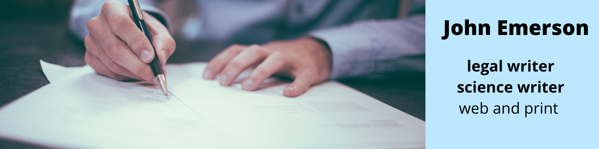
Writer and contact | John Emerson john@jjemerson.com
Your name and contact
Who will I invoice?
Project title

Here are 10 questions to brief me on your writing project. This will help clarify our mutual expectations.
Fill out as much as you can – skip anything not relevant – and email it to john@jjemerson.com.

Where will the writing be published?
e.g. website, email, feature article, blog, report.

What is your preferred deadline?
Even a rough date.

Number of words?
Or range?

Who is your target audience?
Demographic, gender/s, profession, income, interests, aspirations. Specialised, general public…

Who is your target audience?
Demographic, gender/s, profession, income, interests, aspirations. Specialised, general public…

What is its goal?
What would you like the writing to achieve?

What tone of voice would you like?
friendly, authoritative, formal, informal etc.

What research will be required?
Interviews, web, journals, books?

Will I be supplying any photographs?
Or will I be only doing the text?

How will I know if the writing is meeting your goal?
Shall I send a sample draft before completion? Wait until done?

Will my byline will be on the work?
Will there be a named author?

Email to john@jjemerson.com

